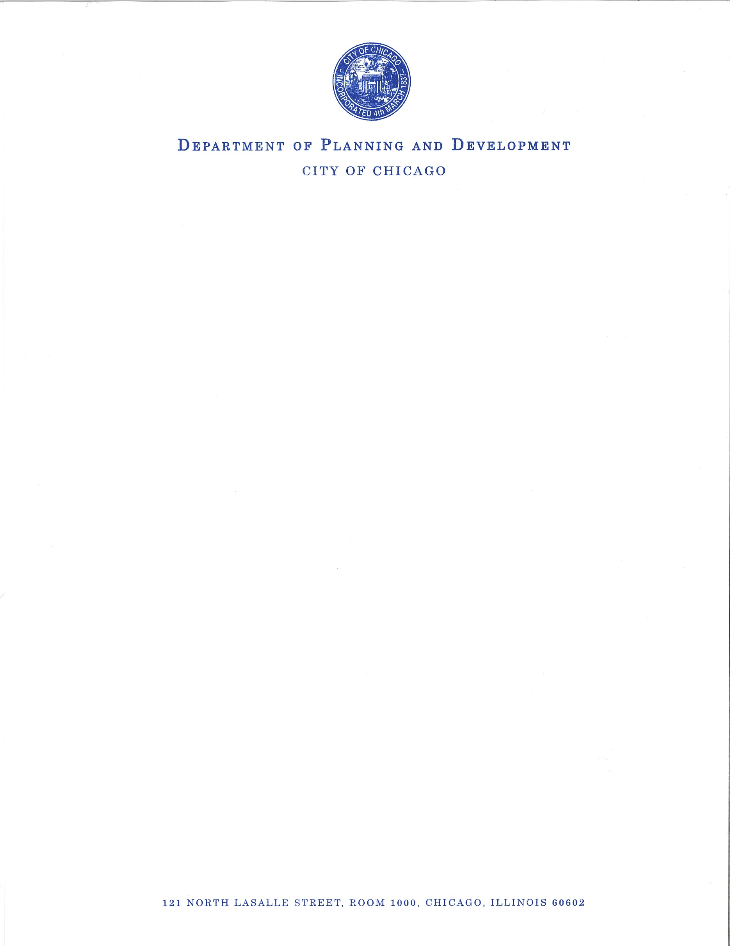

MEMORANDUM

TO: Carlos Ramirez-Rosa
Alderman, 35th Ward

FROM: ______________________________
Patricia A. Scudiero
Managing Deputy Commissioner/Zoning Administrator
Bureau of Zoning and Land Use

RE: 2800-2957 North Milwaukee Avenue
3015 North Elbridge Avenue

DATE: September 7, 2017

Pursuant to your request, my staff has prepared the attached zoning change ordinance(s) for your introduction into City Council. If you have any questions, please feel free to contact me at 744-5765.

PAS/tar

